# Rose Point Community Club

# Boat Owners Committee

June 2016

# Memo of Understanding

For Member Boat Moorage

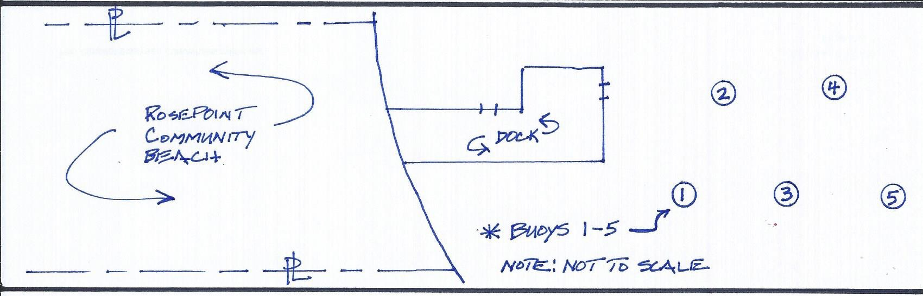

**Formation and Purpose**

The Rose Point Community Club (RPCC) Boat Owners Committee has been formed to manage the boat moorage at the Community Beach. This committee exists to provide an understanding and accountability to our members of the use and allocation of moorage for member boat owners who moor offshore and within the beach property governed by RPCC.

**Buoys**

At present, there are a maximum of five (5) buoys strategically placed offshore. Boat size is restricted to accommodate use of all five buoys and for safety purposes (see below for details). These buoys have been purchased and anchored by past and present member boat owners.

**Buoy Positions, Eligibility and Use Allocation**

Buoy location is referenced from the Rose Point beachfront to the first buoy position #1 and continues northwest from shore for buoys two (#2) through five (#5). Eligibility for buoy usage requires that watercraft owners must be a Rose Point Community Club member in good standing, named homeowner, and currently living at their residence in the Rose Point Community. The registered boat owner (also named homeowner) must provide proof of insurance on the watercraft assigned to the buoy to the Club Treasurer as keeper of all RPCC files and archives. Additionally, the policyholder must name “*Rose Point Community Club”* as additionally insured on their policy. Rose Point Community house renters are not allowed to occupy a buoy position. The Boat Owners Committee will collect proof of insurance and Restricted Dock Fund contributions (see below) and provide these items to the Treasurer on behalf of each five buoy users.

**Safety and Buoy Maintenance**

Member boat owners who are currently allocated to a buoy position (buoy occupant) are responsible for the costs and proper fitness and durability of their allocated buoy. RPCC requires, on a bi-annually annual basis, that each buoy occupant have their allocated buoy, chains and anchoring devices inspected and maintained by a certified professional. Buoy occupants are solely responsible for any and all maintenance and repairs required to keep their buoys in safe working condition. In the event that a buoy or any parts associated with buoy moorage, needs to be replaced, the buoy occupant will be responsible for the costs, anchorage, permits or fees associated with that buoy position.

**Boat Owners Committee**

All buoy occupants will automatically be part of the Boat Owners Committee. The Committee is responsible for providing recommendations for consideration as well as updates to the RPCC Board; providing the Club with copies of insurance documents noted herein; collecting donations from buoy occupants for the Dock Repair and Maintenance Fund (“Dock Fund”); and in general handling any items regarding buoy usage and safety issues as arise.

**Acquiring a Buoy Position**

To accommodate all Rose Point members interested in retaining a buoy and position, the Club Secretary will send a notice to the entire membership when a position becomes available. The Club Secretary will send a notice to the entire membership and handle the process of selection for the next buoy position allocation. Any member interested in attaining a buoy position needs to notify the Club Secretary within 7 days.

Selection will be awarded based upon tenure (who has lived the longest in Rose Point). When a buoy position is vacated, the current buoy occupants will have the first option to move their boat to the open buoy position if desired based on their tenure/longevity within the Rose Point Community. The boat owner awarded the vacant position must, in good faith, start using their buoy within the Spring/Summer months after notification by the Club Secretary. Maximum boat length per buoy is 23’ or less in overall length. Additionally, boat must be registered in the name of the Rose Point Community homeowners’ name.

**Vacating a Buoy Position**

A buoy position may be given up at any time. A boat owner who sells their boat and has no intention of acquiring another boat immediately needs to tell the Club Secretary that their buoy position has become available. A Boaters Committee member who sells their house/property or who no long resides within the Rose Point Community must vacate their buoy position. It has been a long-standing tradition that no buoy is taken away at the termination of a member vacating a buoy. It is customary to leave all buoys in place for another Club member to use and maintain.

**Buoy Occupants Annual Contribution**

In appreciation of usage of the buoys, dock and waterways belonging to the community, and as an act of goodwill towards Club members, the Boat Owners Committee will ask each buoy occupant to make an annual contribution to the RPCC Restricted Dock Maintenance and Repair Fund.This “Dock Fund” will be specifically designated on the Club Treasurer’s Annual Report and presented at every Annual Meeting. The “Dock Fund” can only be used for the expressed purpose of dock maintenance and repair. In addition, these funds may be accrued from year-to-year until needed. Contributions will be presented to the Club Treasurer annually when community dues are collected. A suggested donation of $50 annually is suggested. The Club Treasurer will provide a financial accounting of the “Dock Fund” as part of regular and customary finance reporting at Club Board meetings.

## *Changes and Revisions to this Memo of Understanding:*

Any changes or revisions to this Memo of Understanding must be reviewed and agreed upon by the Boat Owners Committee and approved by the Rose Point Community Club Board.

**Buoy Allocation**

The following buoy allocation/occupancy is as follows as of June 2016 (locations mapped to image at top of page):

* Buoy #1: Owen
* Buoy #2: Futty
* Buoy #3: Hunter
* Buoy #4: Sedillo
* Buoy #5: La Haye

**End of document**